### VR SPEECH

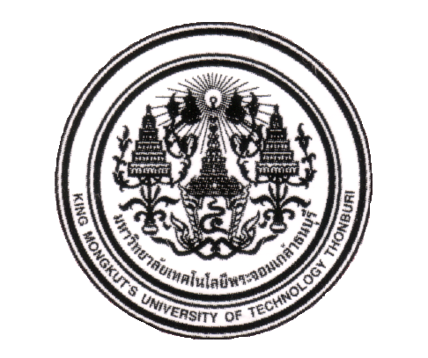

MISTER SORASAK KHUMSUKHA

MISTER SOMKIEAT WONGSEANSUK

A PROJECT SUBMITTED IN PARTIAL FULFILLMENT OF THE

REQUIREMENTS FOR

THE BACHELOR OF SCIENCE IN COMPUTER SCIENCE SCHOOL OF INFORMATION TECHNOLOGY

KING MONGKUT’S UNIVERSITY OF TECHNOLOGY THONBURI

2019